1. 
2. **Agenda**:
   1. Overview of what will be covered in this section.
3. 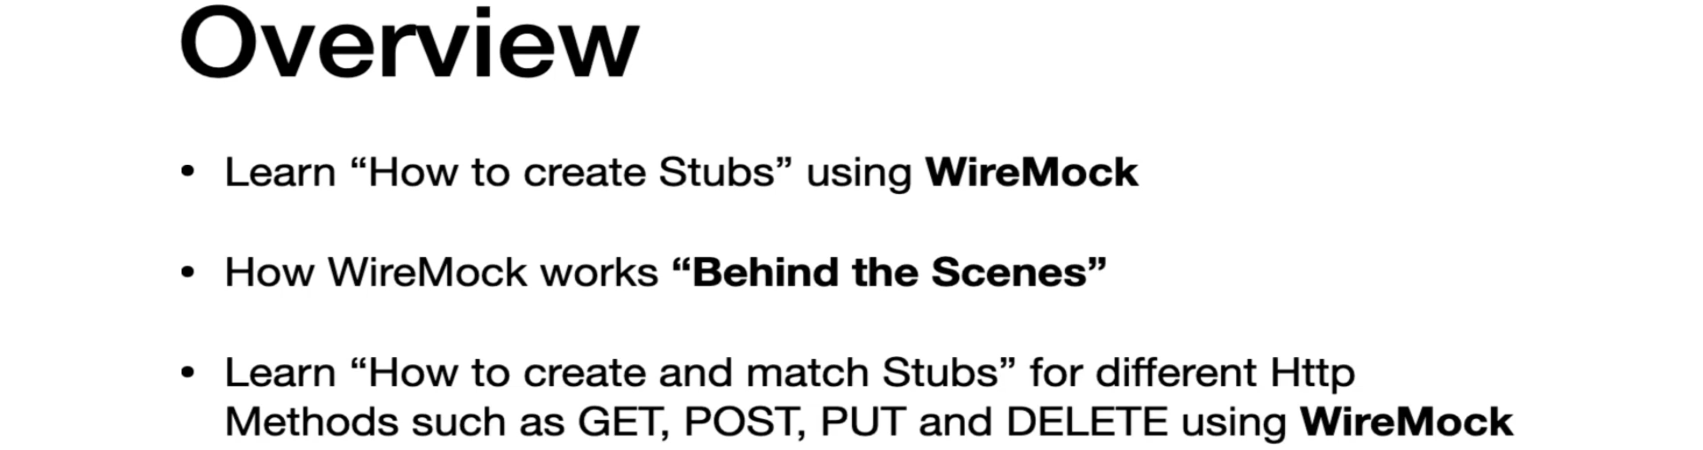
4. 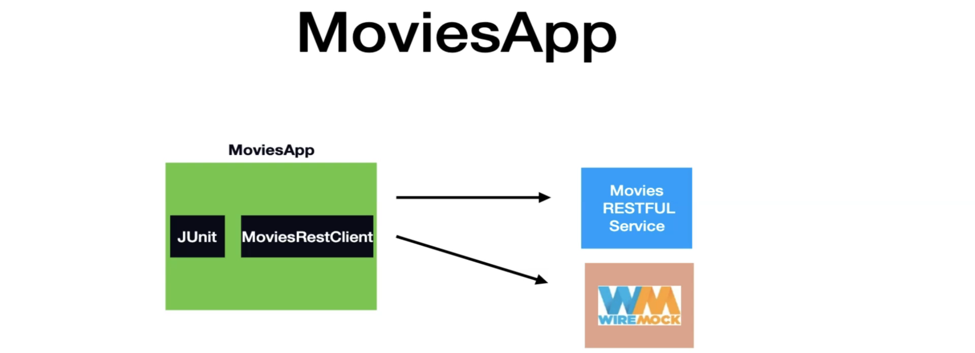
   1. The automated tests that we have as part of Movie App interact with “Movie RESTful Service”.
   2. The goal of this section is to have the REST Client of MoviesApp interact with **WireMock**.